**Assignment**

**Course: Algorithm Analysis (ICT2201)**

**Submission Date: 24/01/22**

1. Write an algorithm to reverse the elements of stack only using stack operations.
2. A full K-ary tree is a tree where every internal node has exactly K children. Use mathematical induction to prove that the number of leaves in a non-empty full K-ary tree is (K − 1)n + 1, where n is the number of internal nodes.

Note: a **k-ary tree** is a rooted [tree](https://en.wikipedia.org/wiki/Tree_(graph_theory)) in which each node has no more than *k* children. It is also sometimes known as a **k-way tree**, an **N-ary tree**, or an **M-ary tree**. A [binary tree](https://en.wikipedia.org/wiki/Binary_tree) is the special case where *k=2*.

1. Given a binary tree, Write an algorithm to print the elements in a new order, as suggested by the example shown below:

[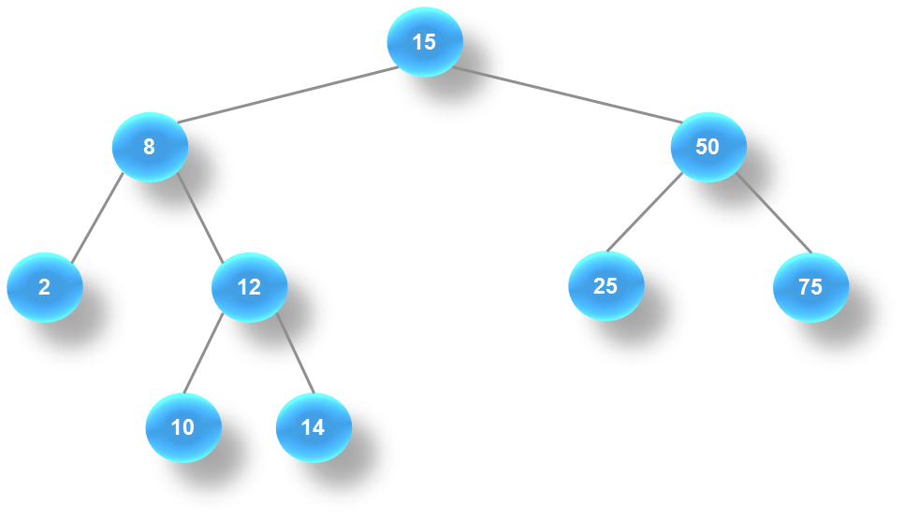](https://sites.tufts.edu/comp15/files/2013/06/bst1.png)

The expected output is: 10, 14, 2, 12, 25, 75, 8, 50, 15.  
  
4. Write an algorithm to compute the sum of all elements in a BST.